SWIFTPAY: MINI PAYROLL SYSTEM

A Project presented to the
College of Information Technology Education
PHINMA University of Iloilo
Rizal, Iloilo City

Submitted in partial fulfillment of the requirements for the degree of
Bachelor of Science in Information Technology
(IT Project Management, Information Systems
(including Database Fundamentals), and Object-Oriented Programming)

Anecita, Lenny Rose
Geroy, Blessed Rose
Madrid, Roseanne
Tamorite, Jules Martin
Valdez, Jerry Mae
Villar, Crisamae

October 2024

- Project Description

SwiftPay is a comprehensive and streamlined payroll management system tailored for small to medium-sized businesses. It is designed to automate and simplify the complexities associated with payroll processing, ensuring accurate salary disbursements, seamless employee management, and secure handling of sensitive payroll data. This system helps administrators efficiently manage employee details, generate accurate payslips, and track payroll activities while giving employees easy access to their profiles and payroll records.

- Project Objectives

General Objectives

To develop a SwiftPay: Mini Payroll System that automates payroll processing, facilitates employee management, and ensures secure user authentication, aiming to streamline payroll operations for businesses.

Specific Objectives

Specifically, this project aims to develop the following:

- User Authentication and Role Management: Implement a secure login system with role-based access for admins and employees.
- Employee Management Module: Create a module for administrators to add, update, and manage employee information, including their roles, positions, and salaries.
- Automated Salary Calculation: Develop a system that automatically calculates employee salaries based on their workdays and basic pay, ensuring accurate payroll.
- Payslip Generation and Access: Implement a feature that generates detailed payslips for each employee, allowing them to view and download their payslips from the employee dashboard.

- Scope and Delimitation

The scope of SwiftPay: A Mini Payroll System focuses on automating payroll processing, including user authentication, employee management, salary calculation, and payslip generation. It allows administrators to manage employee records and handle payroll tasks, while employees can view their profiles and download payslips. The system is designed specifically for small to medium-sized businesses and aims to improve payroll efficiency. Delimitation includes limiting the system's features to basic payroll functions, excluding advanced tax and deduction calculations, leave management, and multi-currency support.

- Software Development Model

In the development of SwiftPay: Mini Payroll System, the team chose the Agile Development Model as a process in developing the system. The Agile Development Model allows us to develop the system incrementally and iteratively, ensuring continuous collaboration with stakeholders throughout the project. This approach provides flexibility in adapting to changing requirements, encourages frequent testing and feedback, and enables us to deliver functional modules in shorter time frames.

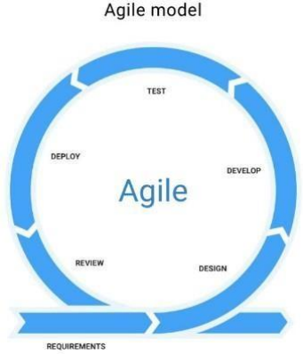

Figure 1: Agile Development Cycle

PLANNING

In this phase, we define the project scope and objectives, including automating payroll calculations and managing employee information. Gather the prioritize user stories and requirements, such as calculating salaries and generating payslip.

DEPLOY

In this phase, we prepare for deployment by finalizing documentation and deployment procedures. Deploy the payroll system to the production environment, ensuring all features are correctly implemented. Monitor the system post-deployment and provide support to resolve any issues that arise.

TEST

In this phase, we conduct unit testing individual components such as payroll calculations and employee data management. Perform integration testing to ensure modules work together correctly and conduct user acceptance testing to validate that features meet requirements.

MAINTENANCE

In this phase, ongoing system maintenance is performed to ensure the system remains functional and up-to-date. This includes fixing bugs, applying security patches, and updating features as needed. Regular system health checks are also conducted to ensure continued smooth operations.

REVIEW

During this phase, we review the system’s performance and user feedback to identify areas for improvement. This involves gathering input from administrators and employees using the system, analyzing how well the system meets the business needs, and planning enhancements or optimizations for future versions.

- Project Timeline

Milestone | Date© | Description
Planning | August 20 – August 31, 2024 | The team define the project's scope, objectives, and deliverable, creating a comprehensive project plan that includes timelines, resource allocation, and risk management strategies.
Designing | September 1 – September 10, 2024 | We create detailed system architecture, database schema, and user interface designs. This phase will finalize all design elements, ensuring they meet the project requirements and providing a blueprint for the development process.
Development | September 11- October 10, 2024 | In development phase involves coding and building the core functionalities, user interfaces, and integrating the system with external applications. This phase will produce a functional version of the payroll system, including essential features and integration.
Testing | October 11- October 20, 2024 | Our system will undergo unit testing, integration testing, and user acceptance testing (UAT). This ensures that all components function correctly, meet requirements, and are ready for deployment.
Deployment | October 21 – October 24, 2024 | Deployment phase includes preparing the production environment, executing the system deployment, and ensuring a smooth transition to live operation. This phase will make the payroll system available to end-users.
Review | October 25 – October 28, 2024 | The team will finalize user training, complete documentation, and gather initial feedback from users. This phase will address any immediate issues and confirm that all project deliverable are met.
Launch |  | Launch phase marks the official handover of the payroll system to stakeholders, with ongoing post-implementation support and feedback collection. This phase will ensure that the system operates effectively and meets user expectations, closing the project formally.

- Project Team Roles and Responsibilities

Name | Role | Responsibilities
Crisamae Villar | Project Manager | Responsible for the effective planning, execution, and completion of the project, while managing resources, timelines, and stakeholder expectations to deliver a high-quality payroll solution on budget.
Roseanne Madrid | Business Analyst | Engage with stakeholders to gather, analyze, and document business requirements and needs.
Lenny Rose Anecita | Business Analyst | Use tools like DFDs, UML diagrams, and process flows to visualize project requirements.
Blessed Rose Geroy | Documentator | Prepare comprehensive documentation for the project, including technical and non-technical documents.
Jerry Mae Valdez | Documentator | Manage document versions to keep track of changes and updates.
Jules Martin Tamorite | UI/UX Design | Develop the look and feel of the application, including color schemes, typography, and layout.

- Implementation
Wireframes:

Login:
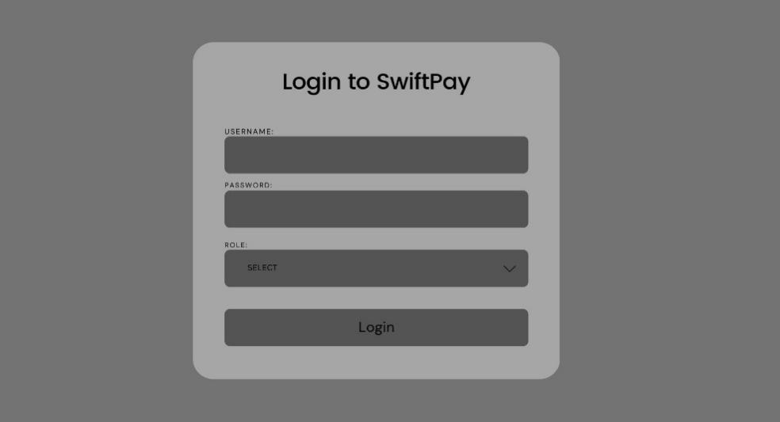
Admin Dashboard:
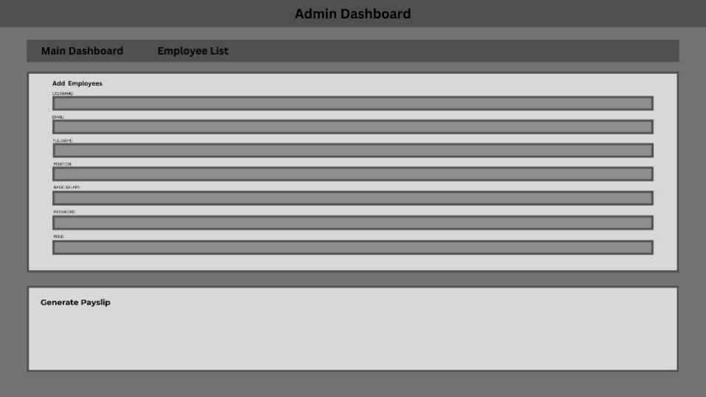
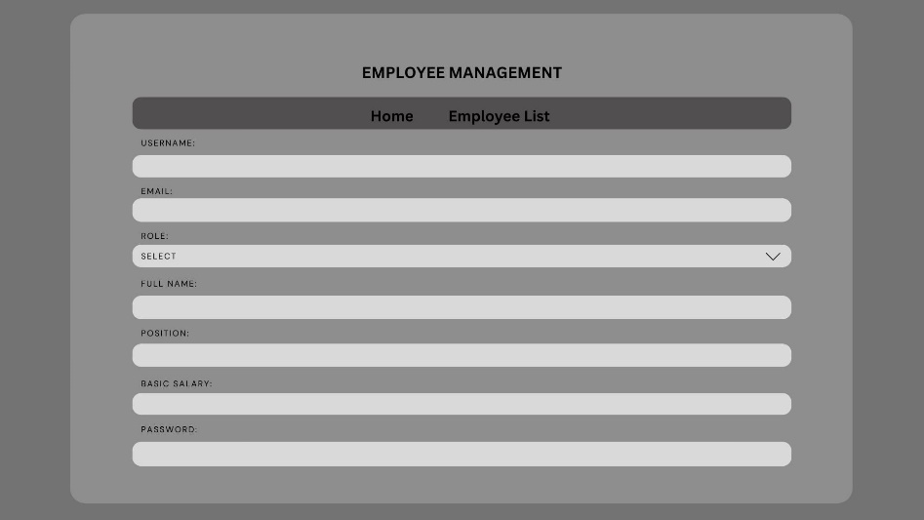
Employee management:

Employees List Table:
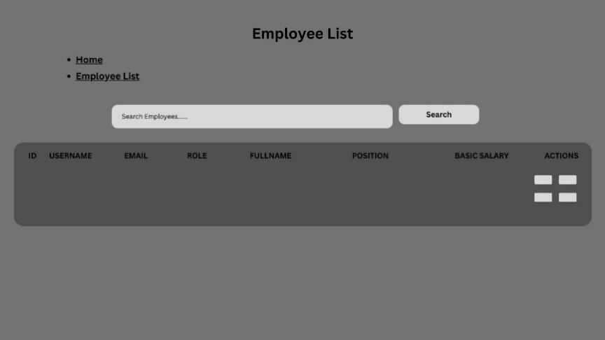
Employee Table:
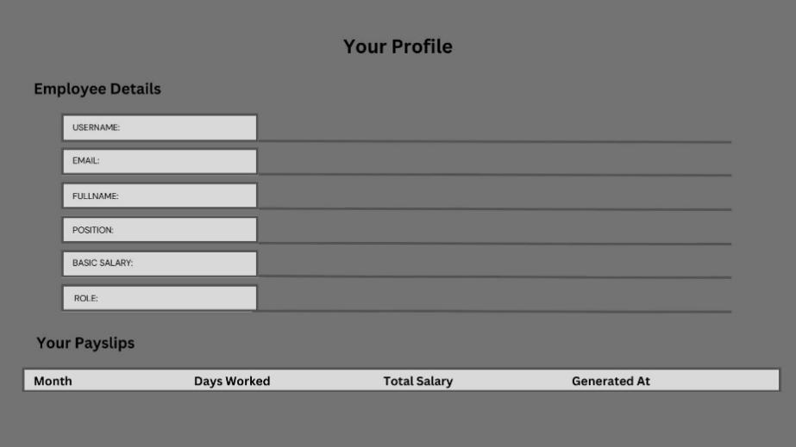

PHP Code:
Login.php
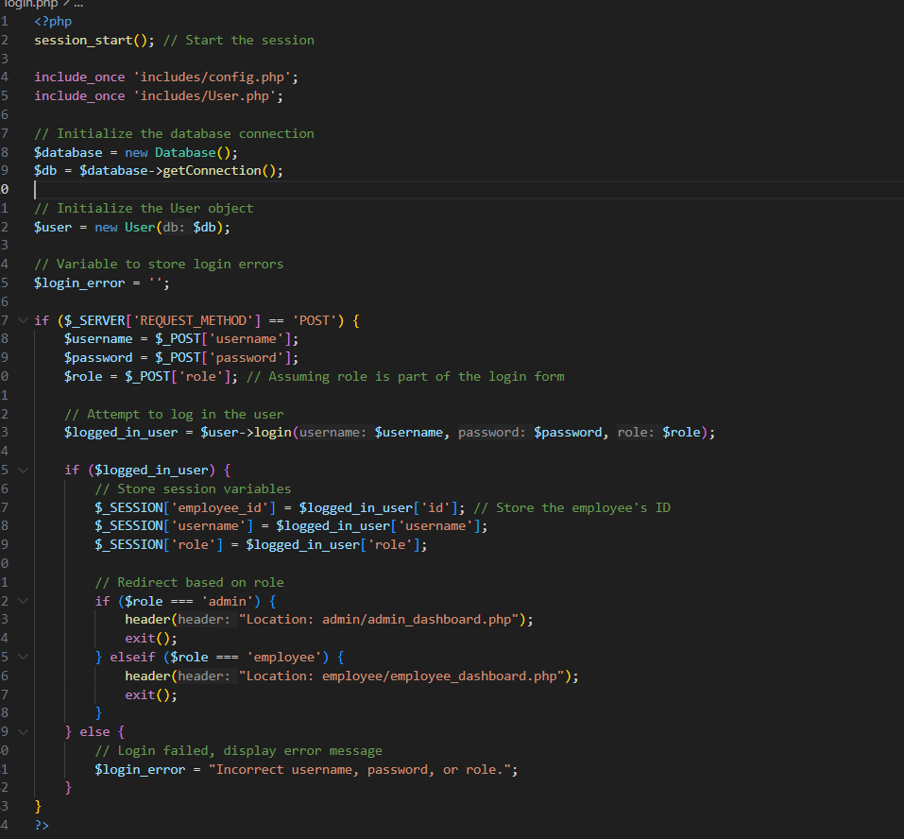
Index.php
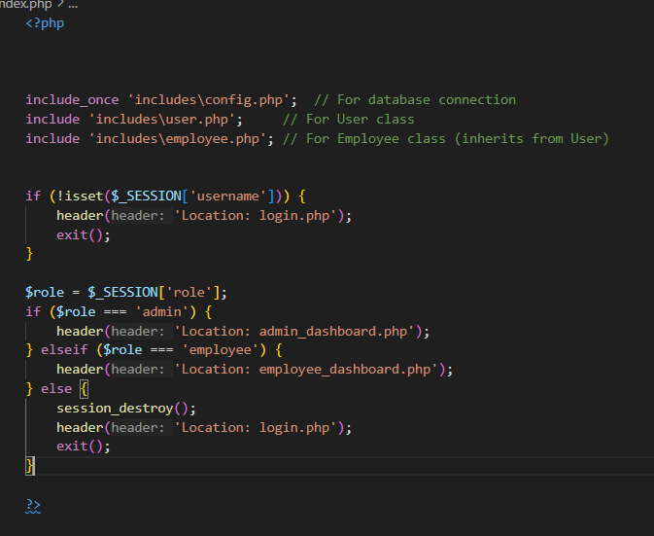
Dash_board.php
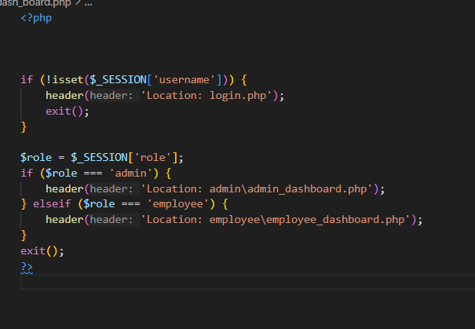
User.php
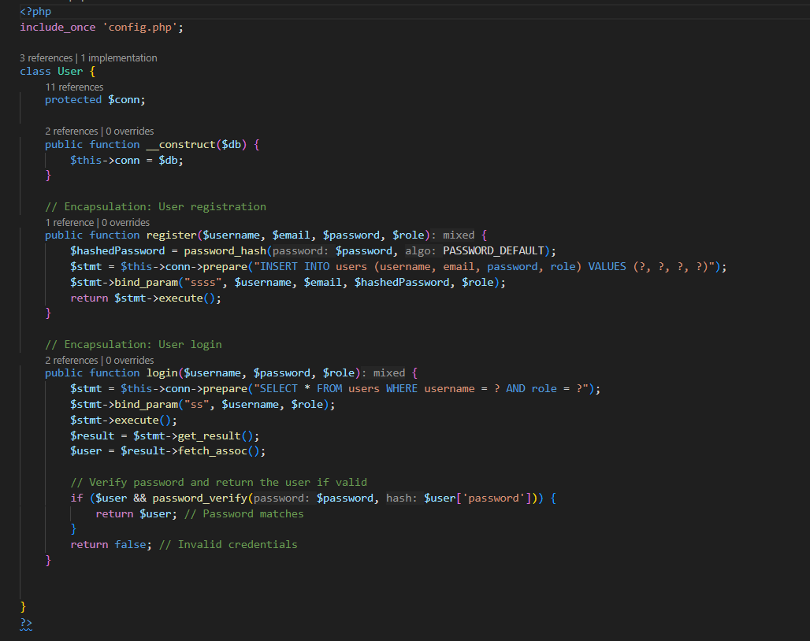
Payslip.php
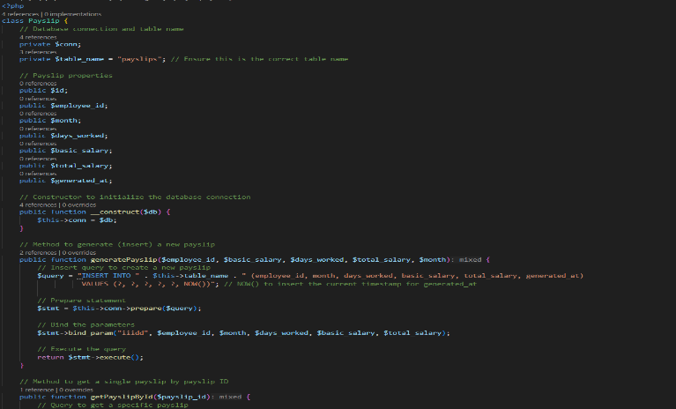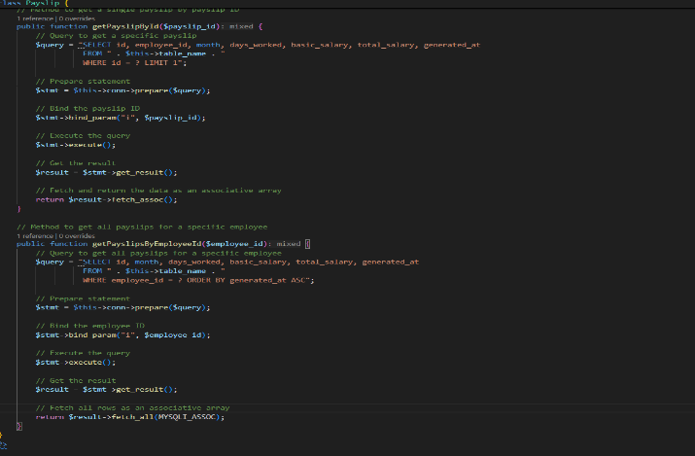
Employee.php
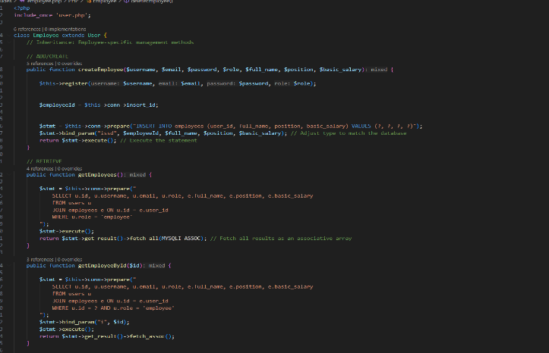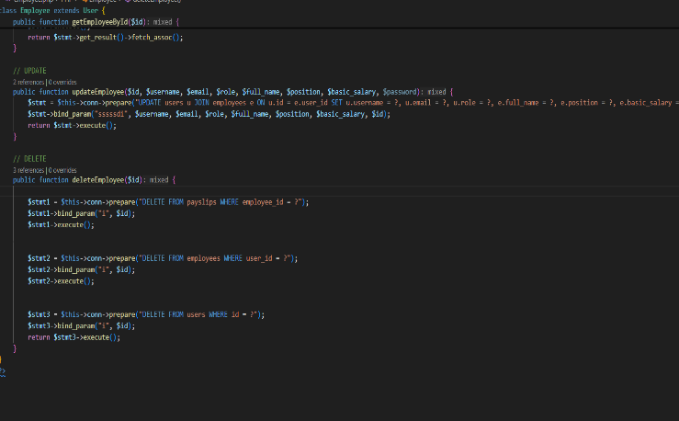
Config.php
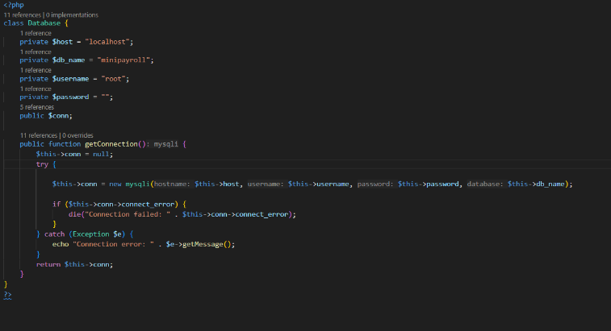
Generate_payslip.php
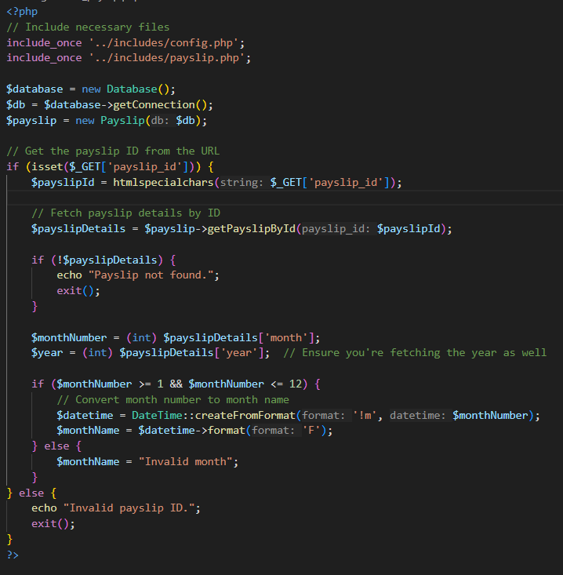
Employee_dashboard.php
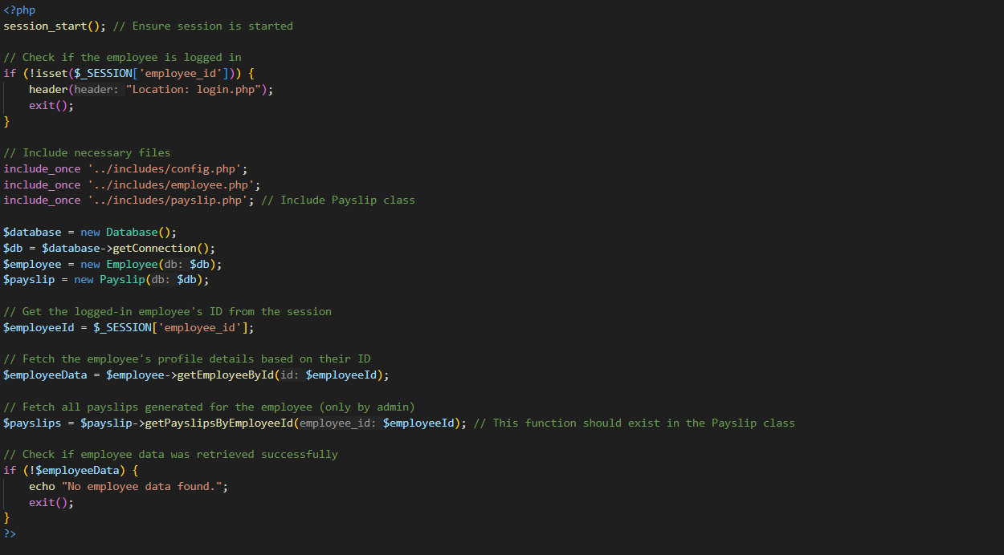
Employee_table.php
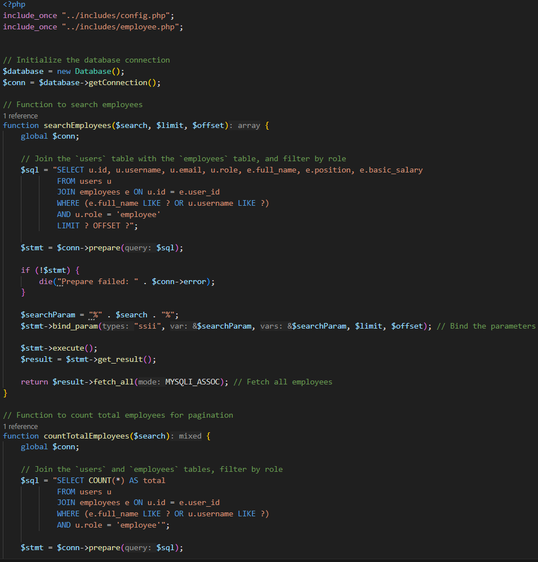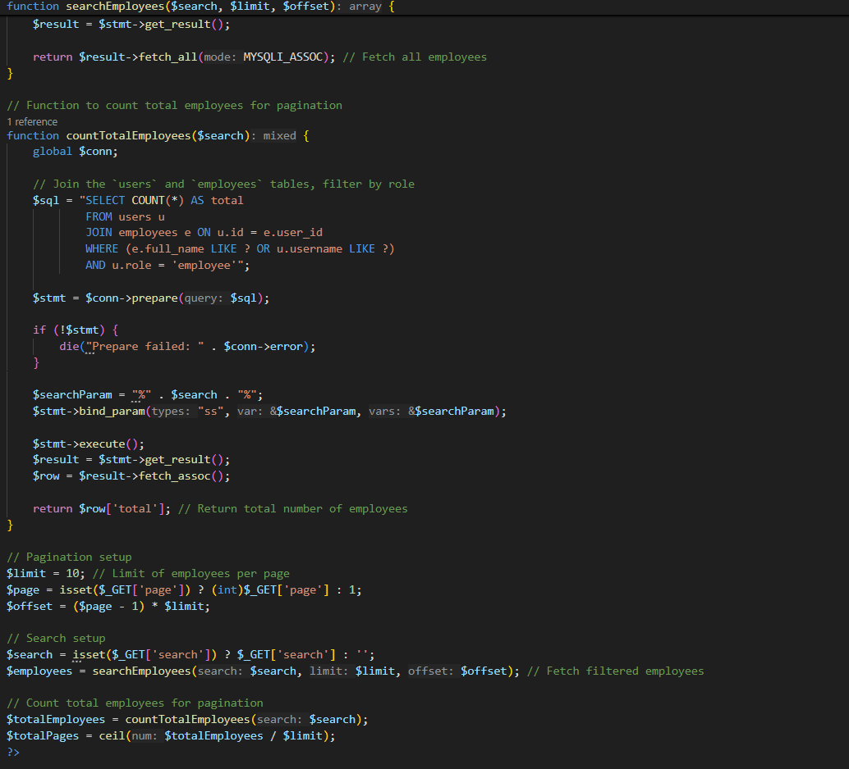

Employee_management.php
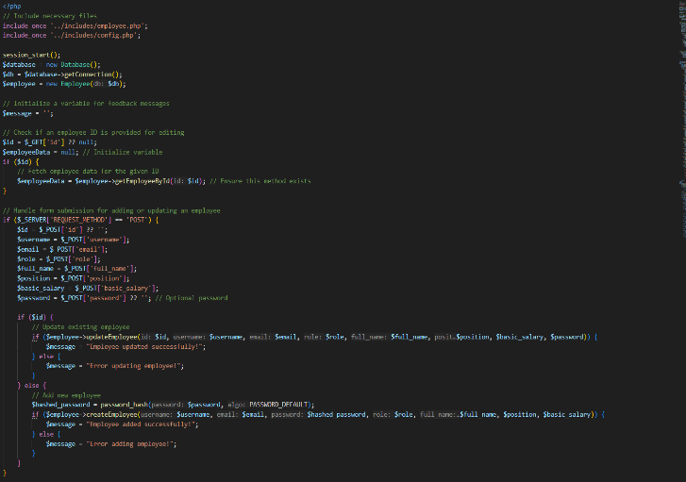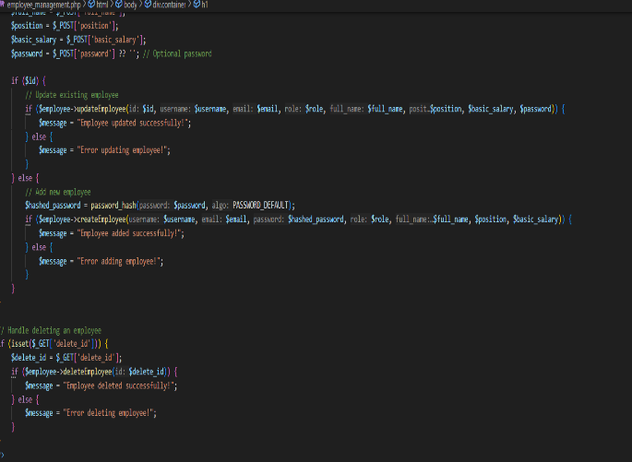
Admin_dashboard.php
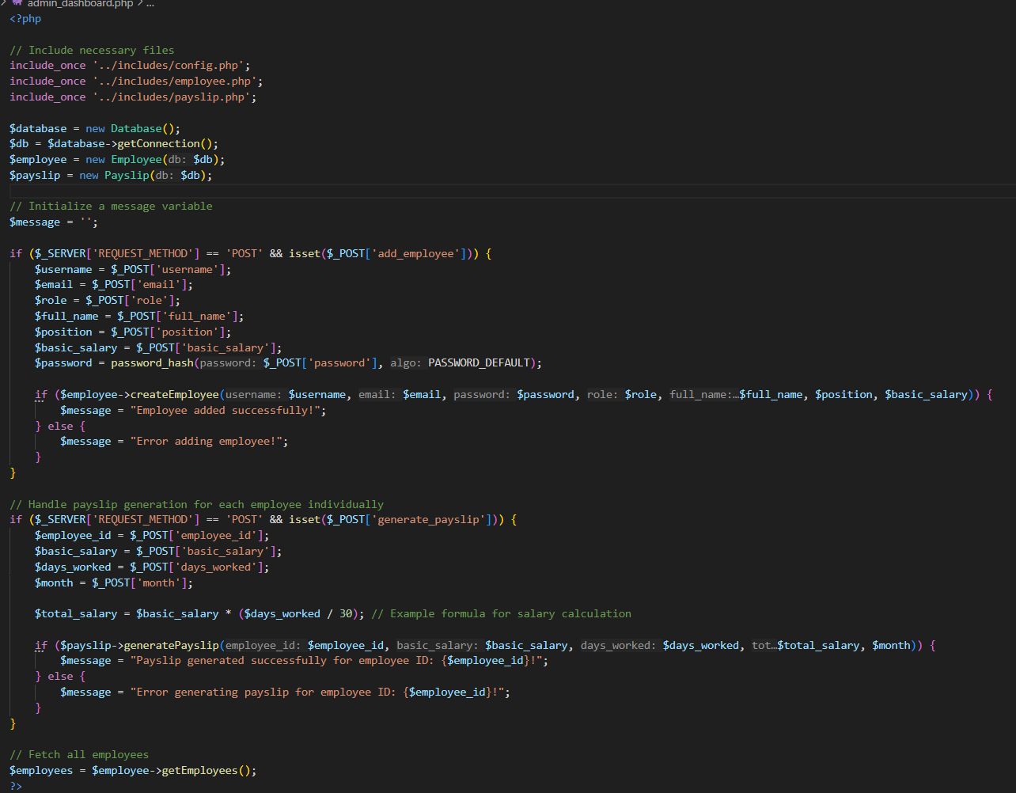

Data Flow Diagram:
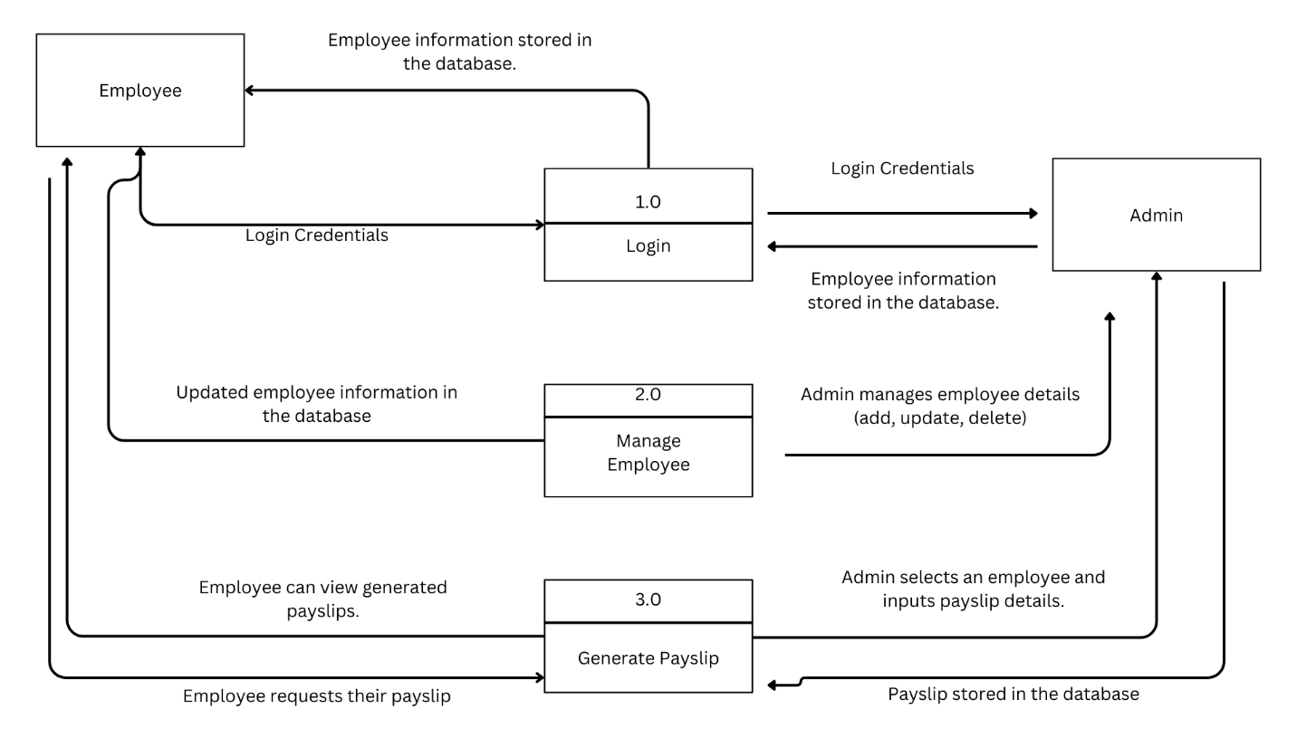

UML Diagaram Add On:
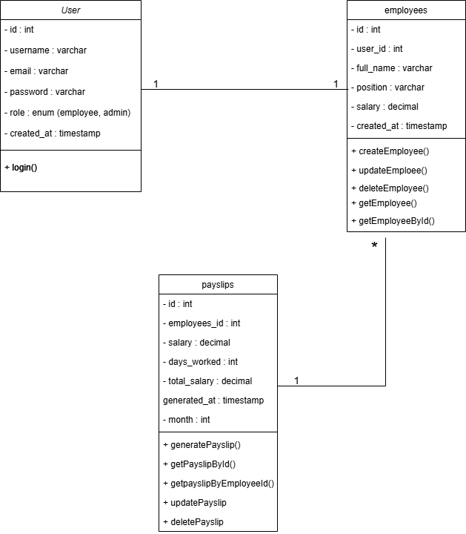

STATEMENT OF THE PROBLEM:

Small and medium-sized enterprises (SMEs) often struggle with managing their payroll processes efficiently. Manual computation of salaries can lead to errors, resulting in inaccurate payments and delays. Tracking employee attendance becomes time-consuming and prone to mistakes without a streamlined system. Additionally, the lack of automation in generating payslips and ensuring accurate records poses a challenge for business owners. SwiftPay, a mini payroll system, addresses these issues by automating salary calculations, generating payslips, and simplifying employee management.

